ELEC-2110

Electric Circuit Analysis

FROM: Jacob Howard

TO: Markus Kreitzer

DATE: January 15, 2020

LAB SECTION: 002

Introduction to MultiSim: DC Analysis

# Introduction

The Objective of Lab 1 was to learn the basic features of the MultiSim Circuit Builder program. MultiSim is a circuit simulation software tool. This tool is a great way to learn circuit education in a safe environment, providing a circuit simulation without expensive tools and preventing possible damage to equipment and to the user.

# Exercise 1

In exercise 1, we were asked to use MultiSim to find V0 and Ix in the circuit in Fig. 1 [1]. Figure 1 is below.

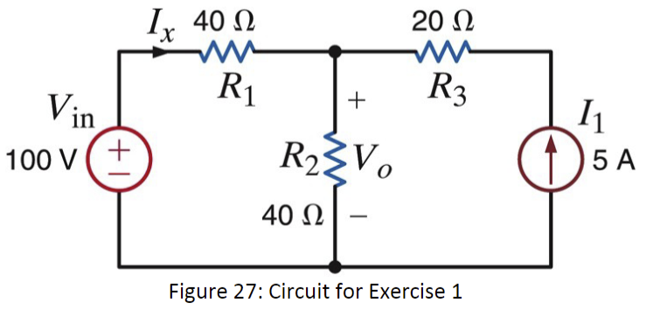

*Figure 1*

Figure 1 was used to construct a circuit in Multisim so we could use Multisim to calculate V0(Unknown Volatage) and Ix (Unknown Current). The circuit constructed is below in figure 2.

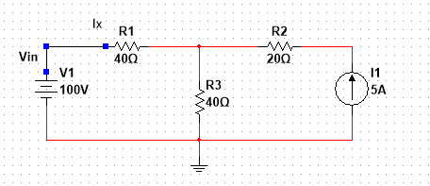

*Figure 2*

Using the circuit constructed in Multisim it was able to calculate V0 and Ix. Found data is listed in Table 1 below.

|  |  |
| --- | --- |
| **V0** | 150 V |
| **Ix** | -1.25A |

*Table 1*

# Exercise 2

In exercise 2, we were asked to use MultiSim to find V0 and the power supplied by the 6-V source in Fig. 3. Figure 3 is included below [1].

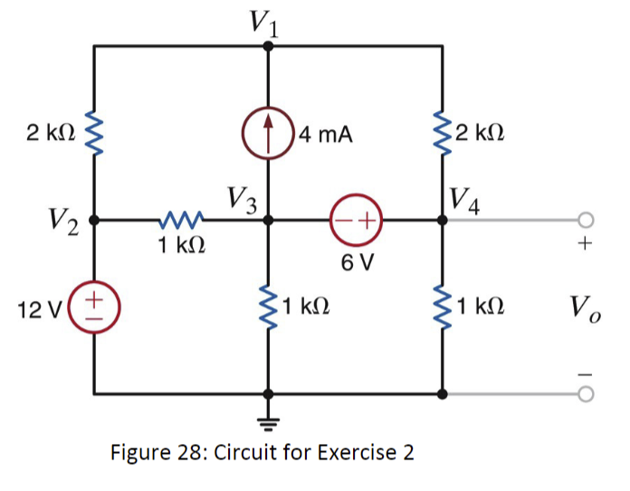

*Figure 3*

Using figure 3, a circuit was constructed in MultiSim so the software could be used to calculate V0 and the power supplied by the 6-V source. Below, in figure 4, is the circuit constructed in MultiSim.

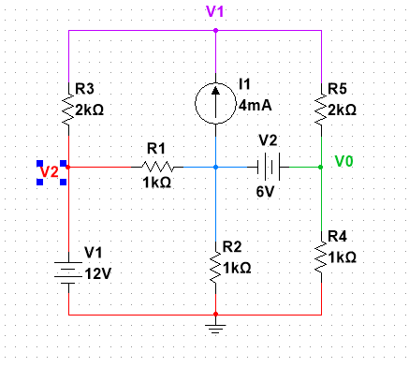

*Figure 4*

Using the circuit constructed in MultiSim from figure 4, The software was able to calculate V0 and the power supplied by the 6-V source. The data collected is listed below in chart 2.

|  |  |
| --- | --- |
| **V0** | 7.69231 V |
| **6-V Source** | 27.69231 V |

*Table 2*

# Exercise 3

In exercise 3, we were asked to use the dc sweep feature of MultiSim to plot V0 as the voltage Vin is varied between 50 V and 150 V in steps of 10 V in the circuit of Fig. 5. Figure 5 is listed below [1].

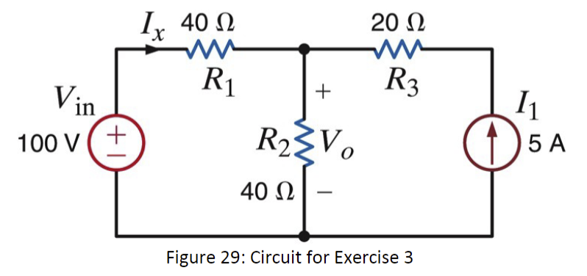

*Figure 5*

Using Figure 29 to construct the circuit and the dc sweep feature in MultiSim, MultiSim was able to show me a graph on how the voltage and the current varies. The circuit constructed in figure 6and the graphs in figure 7 and 8 are below.

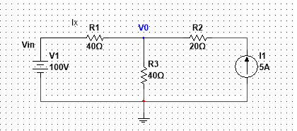

Figure 6

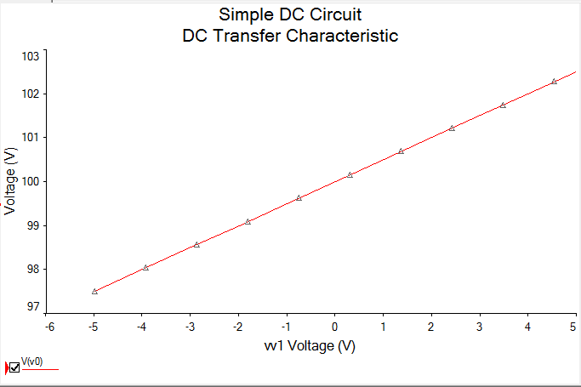

*Figure 7 (Voltage Vary Graph)*

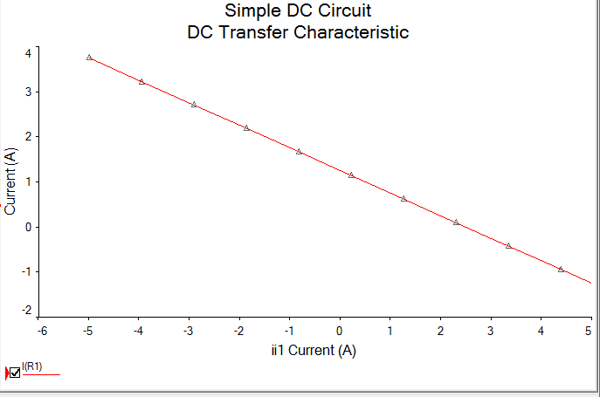

*Figure 8 (Current Vary Graph)*

# Exercise 4

In exercise four, we were asked to use Figure 9 and MultiSim to solve for the voltage V0 as Rb varies from 250 Ω to 3 kΩ in increments of 25 Ω. Also solve for the power dissipated in Rb ( P0 ) for each value of resistance. Figure 9 is below [1].

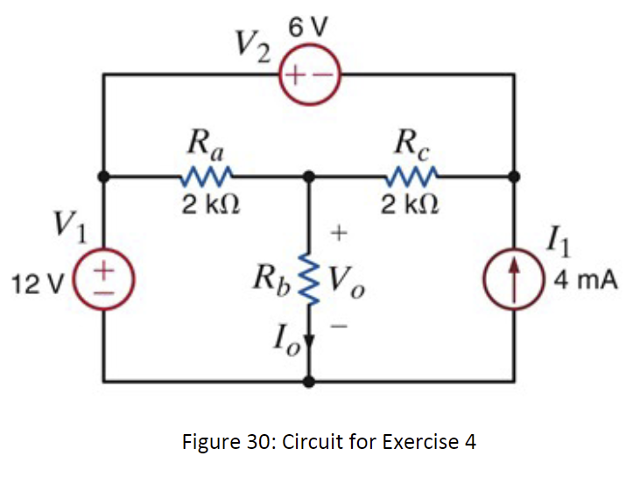

*Figure 9*

Using Figure 9 to construct a circuit, MultiSim was used to display a graph for the voltage V0 as Rbvaries from 250 Ω. The circuit constructed from figure 9 is shown below. The graphing data received from Multisim is also shown below in figure 11 to display V0 as Rb varies and P0 for each value of resistance.

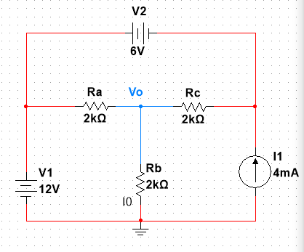

*Figure 10*

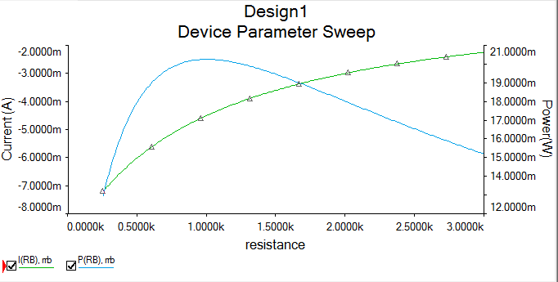

*Figure 11*

*(Voltage V0 as Rb Varries Graph Green)*

*(Power P0 for each value of resistance Blue)*

# Exercise 5

In exercise five, we were asked to Determine I0 in the circuit in Fig. 12 using MultiSim. Figure 13 is shown below [1].

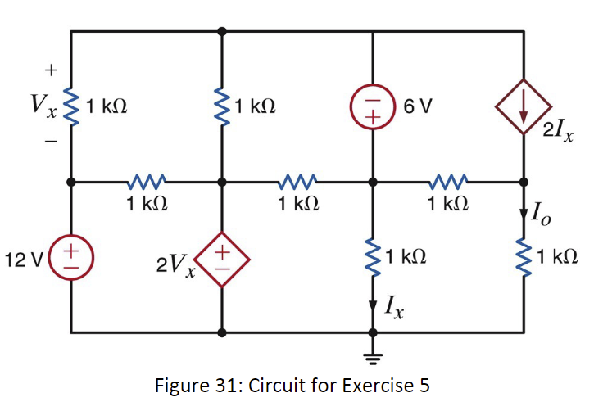

*Figure 12*

Using MutliSims online tool, a circuit was constructed to find I0. The circuit constructed is show below in figure 13 along with I0 in Table 3.

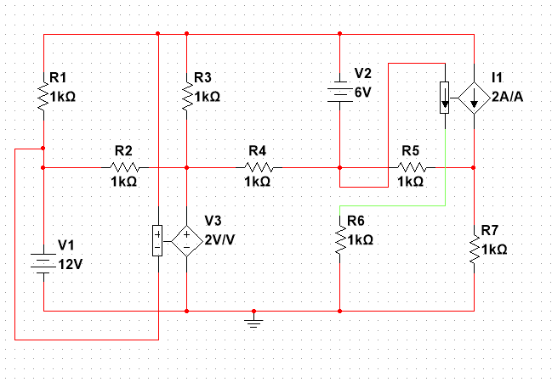

*Figure 13*

|  |  |
| --- | --- |
| **I0** | -48mA |

*Table 3*

# Conclusion

This lab was used as an introduction on how to use MultiSim. The lab went step by step to show us how to build and simulate a circuit and showed how useful and powerful MultiSim can be. We were able to learned the basics of MultiSim and how to construct circuits, along with displaying certain data, but I did run into some problems. In one instance, I received an incorrect answer. The TA and some fellow students were very helpful at correcting my errors. Overall, this lab was a good way to introduce everyone on the basics of MultiSim and how to use it.

# Bibliogrophy

[1] Markus Kreitzer Suraj Sindia Elizabeth Devore Bei Zhang. “EXPERIMENT 1 Introduction to Multisim”. Updated In: (January 2020)

url:ftp://ftp.eng.auburn.edu/pub/irwinjd/lab_manuals/Lab%201_Multisim_Introduction%20and%20DC%20Analysis.pdf.